**Practical Task 1:** Install and Configure Azure CLI and PowerShell

Requirements:

• Install Azure CLI and Azure PowerShell on your local machine. 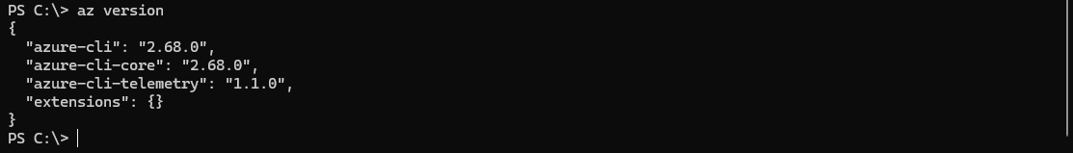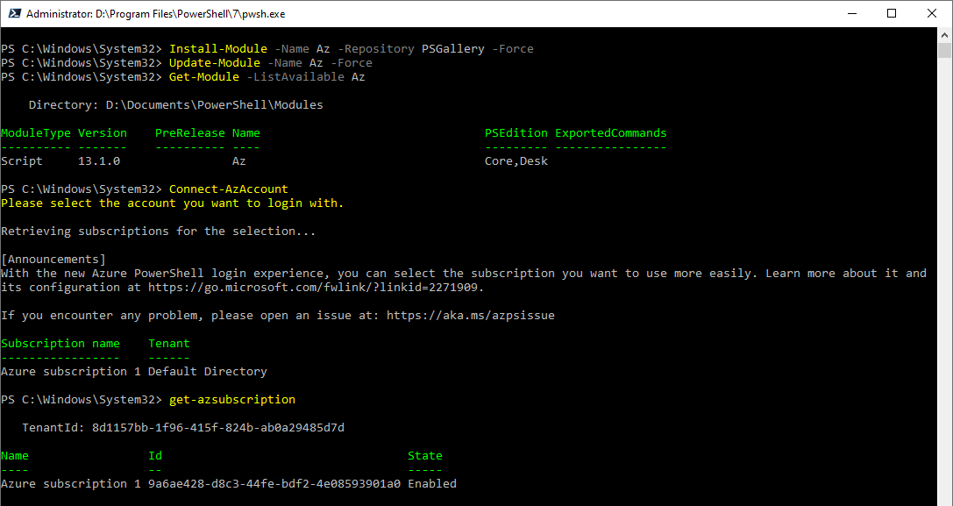

• Verify the installation by checking the versions of Azure CLI and PowerShell modules. 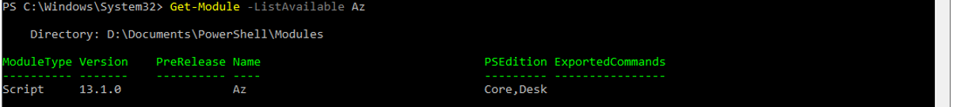

• Log in to your Azure account using both Azure CLI and PowerShell. 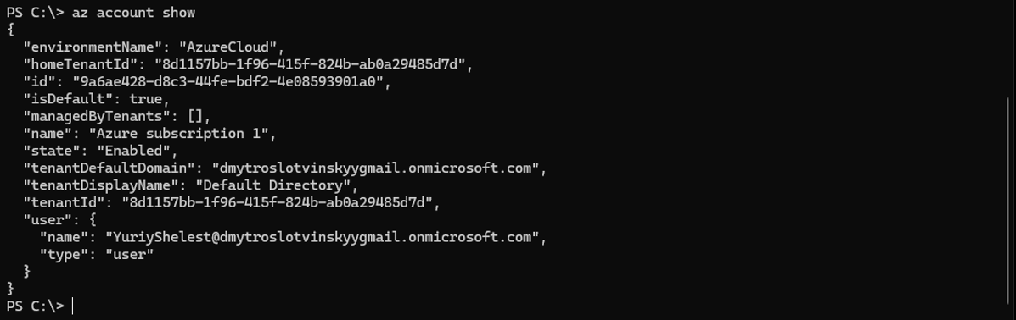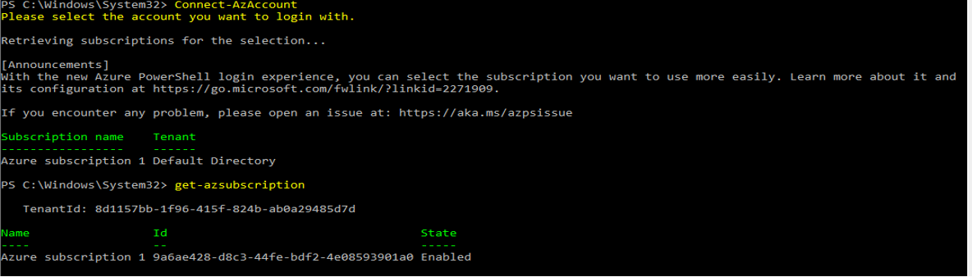

• List all available subscriptions in your Azure account using both tools. 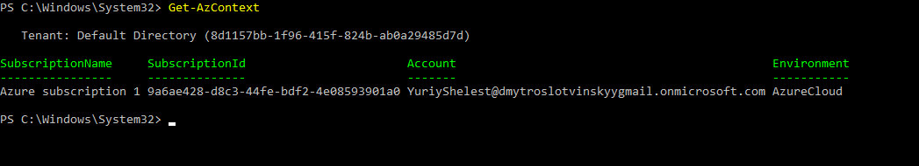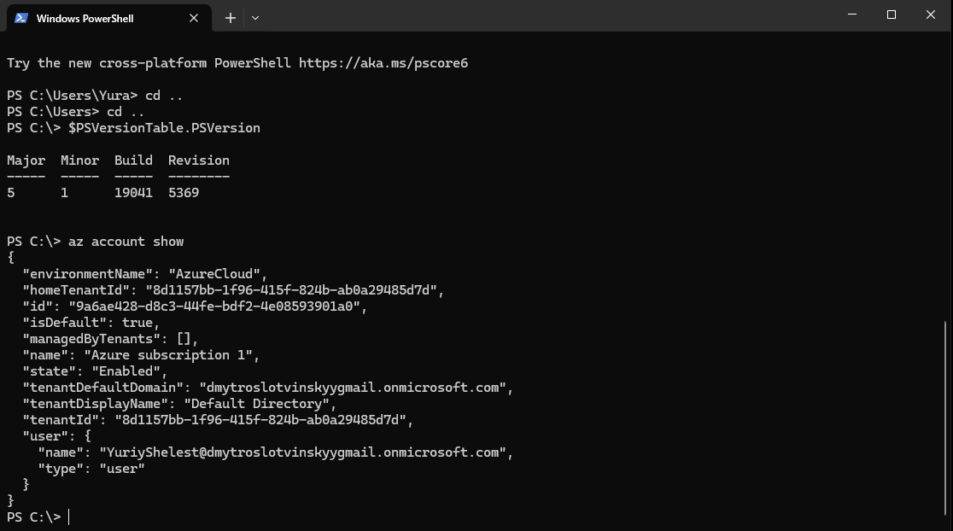

**Practical Task 2:** Create and Manage Resource Groups Requirements:

• Use Azure CLI to create a new resource group named MyResourceGroup in the East US region. 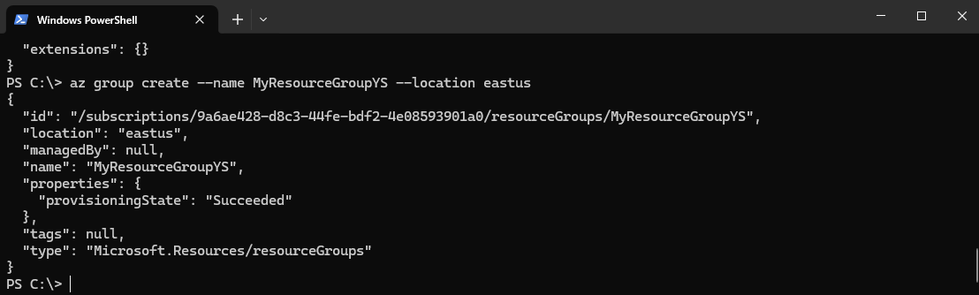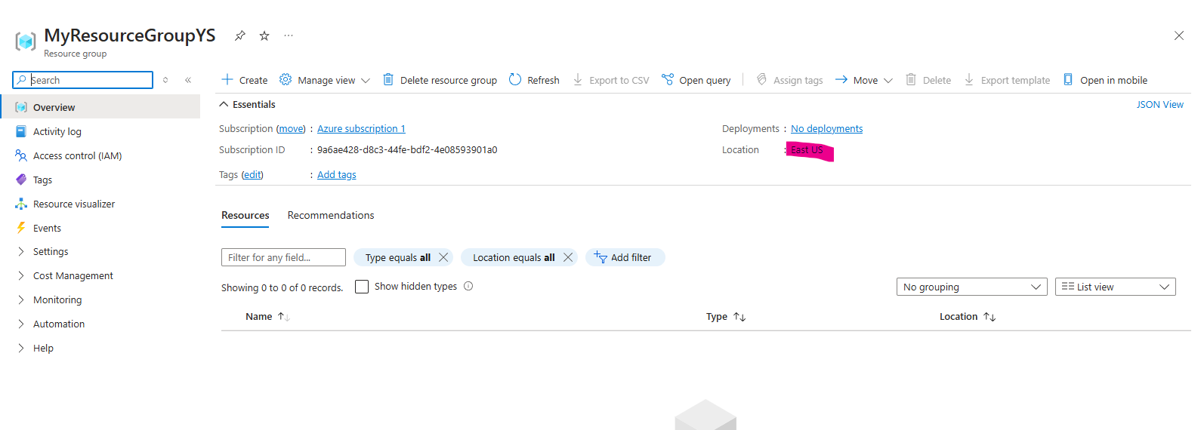

• Use Azure PowerShell to create a new resource group named MyPSResourceGroup in the West Europe region. 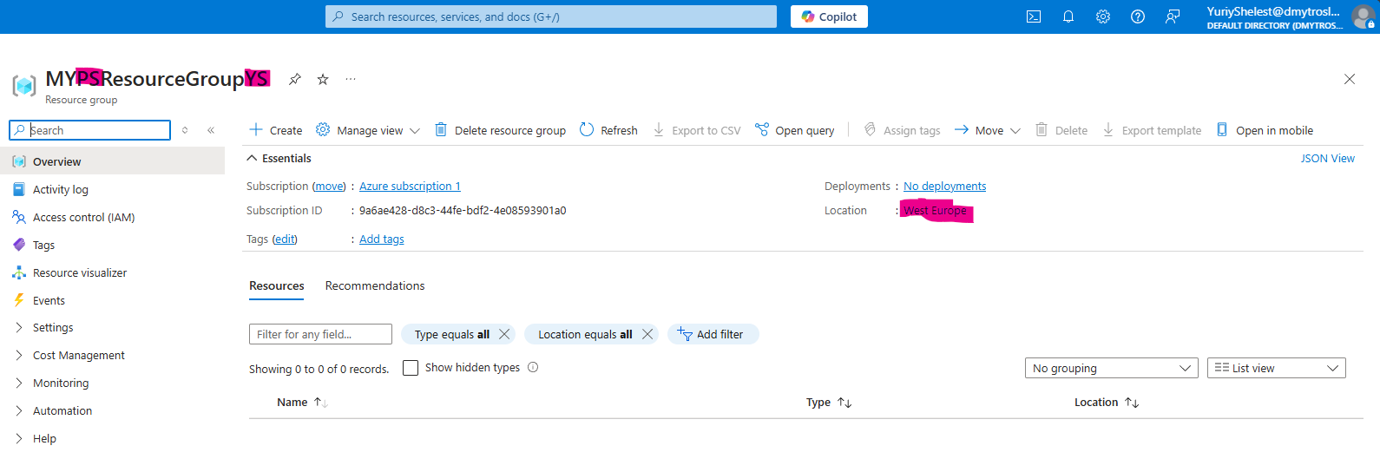

• List all resource groups in your subscription using both CLI and PowerShell. 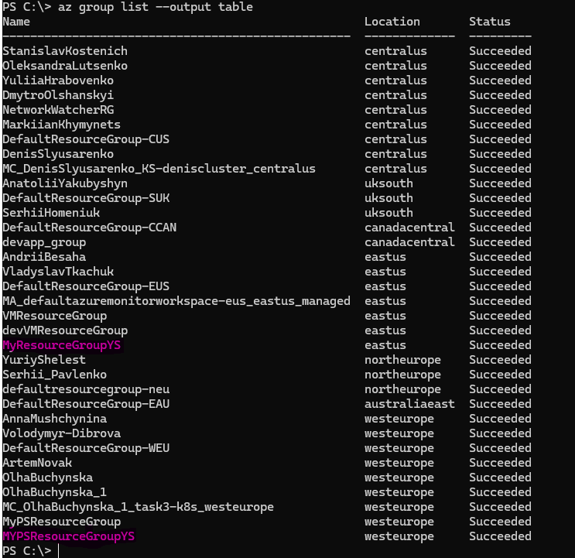 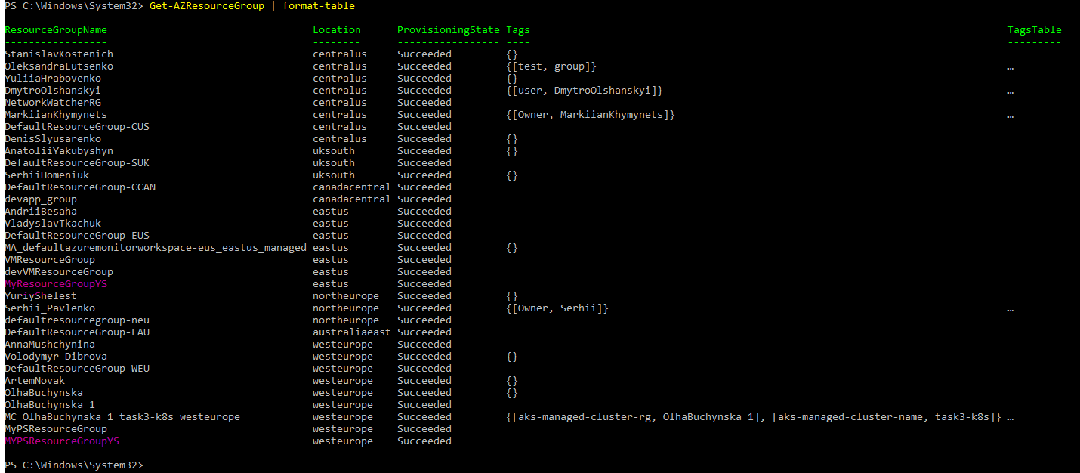

• Delete the resource group MyResourceGroup using Azure CLI. 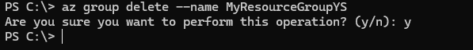

• Delete the resource group MyPSResourceGroup using Azure PowerShell. 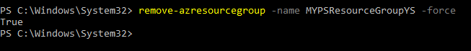

**Practical Task 3:** Deploy and Manage Virtual Machines using Azure CLI and PowerShell Requirements: • Use Azure CLI to create a new virtual machine named MyVM1 in a new resource group VMResourceGroup. 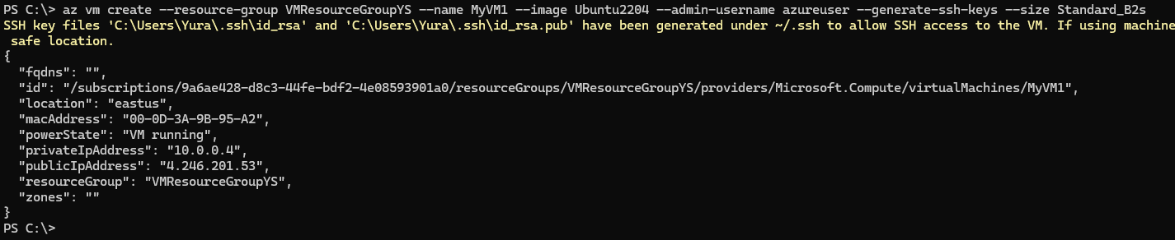 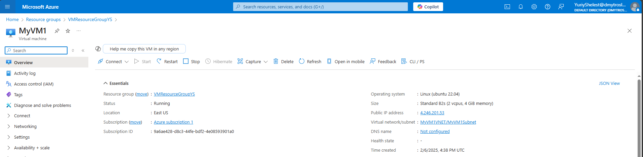

• Use Azure PowerShell to create another virtual machine named MyVM2 in the same resource group. 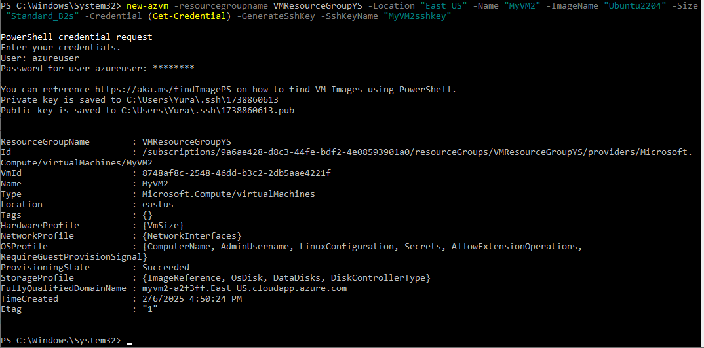 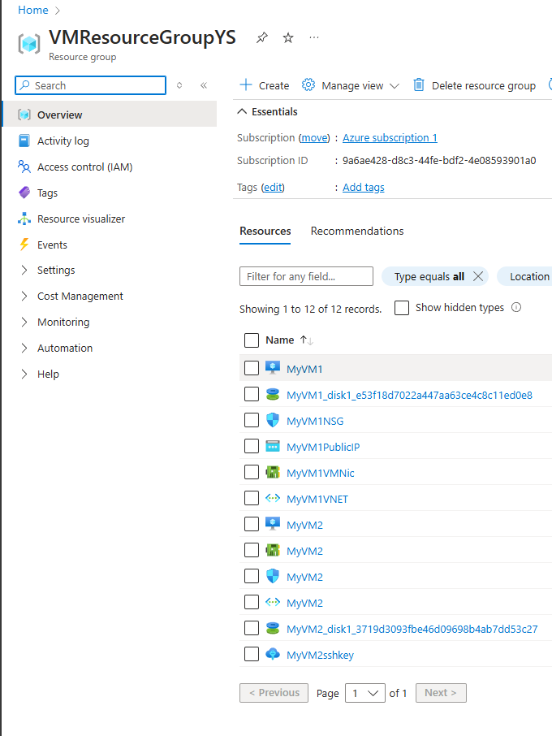• Retrieve details about both virtual machines using both CLI and PowerShell. 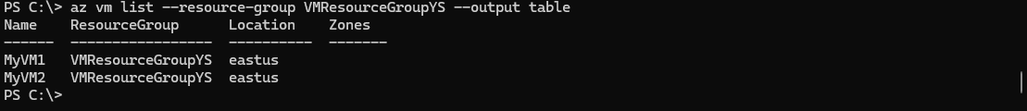 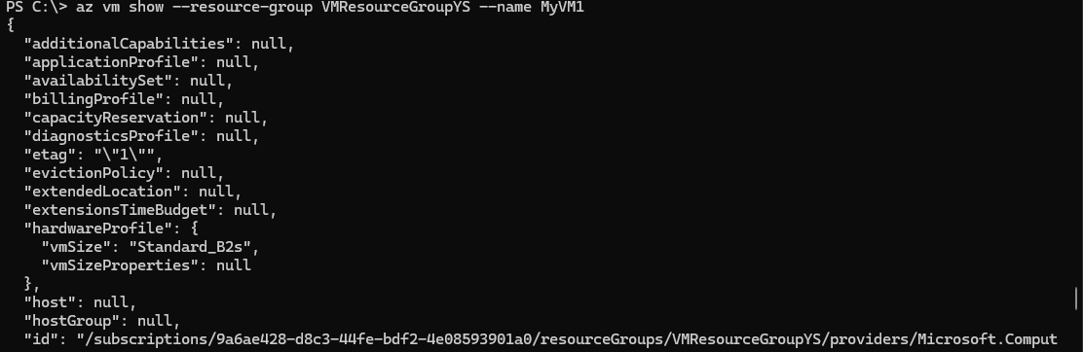 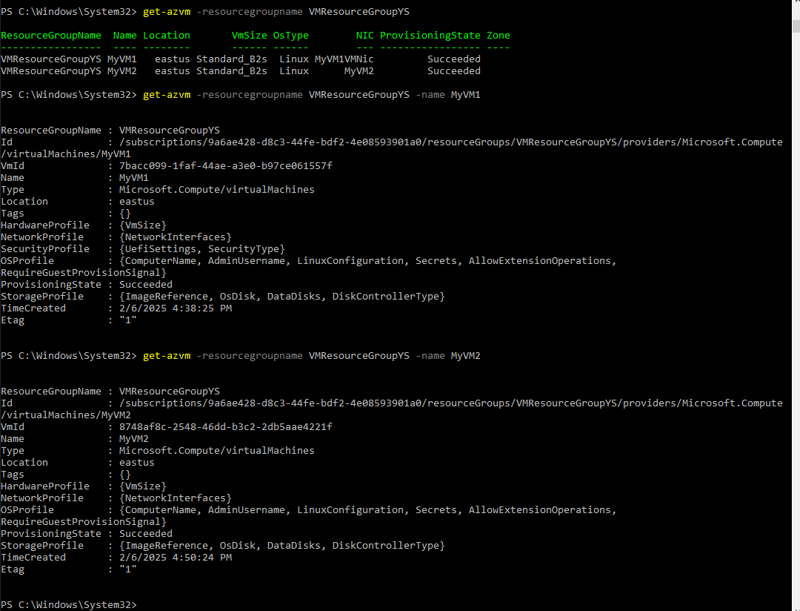

• Stop MyVM1 using Azure CLI and MyVM2 using Azure PowerShell.  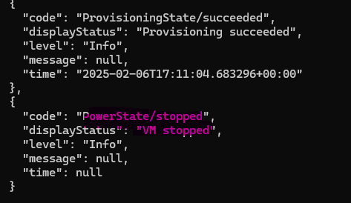 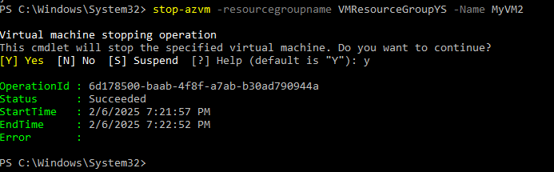 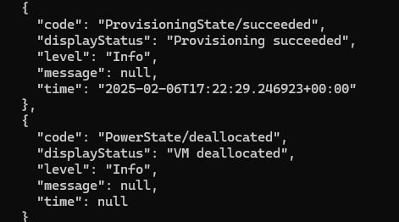

• Delete the virtual machines using the respective tools.  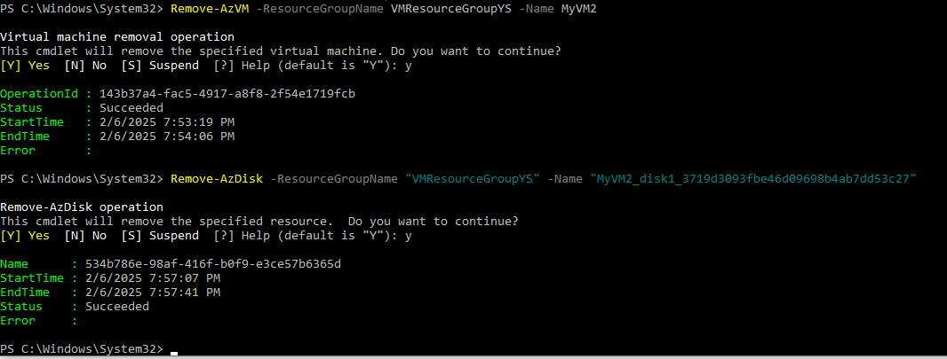

**Practical Task 4:** Manage Storage Accounts using Azure CLI and PowerShell Requirements:

• Use Azure CLI to create a new storage account named mystoragecli in the East US region. 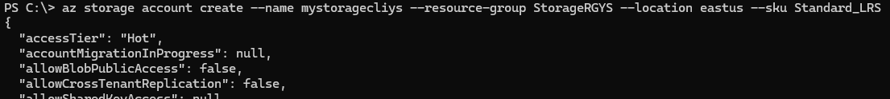

• Use Azure PowerShell to create a new storage account named mystorageps in the West Europe region. 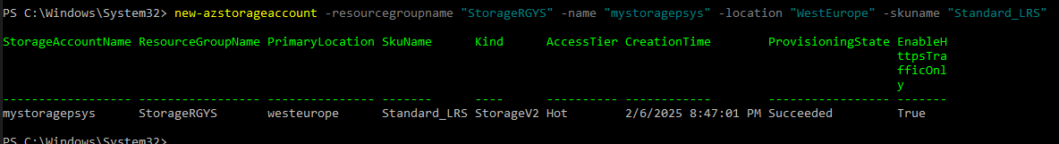

• List all storage accounts in the subscription using both CLI and PowerShell. 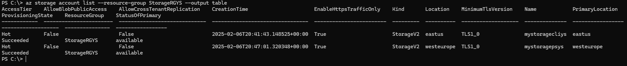 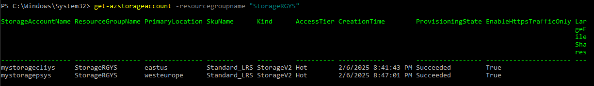

• Retrieve the connection string for the mystoragecli storage account using Azure CLI. 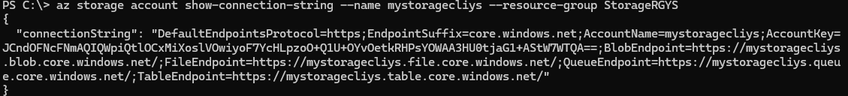

• Retrieve the connection string for the mystorageps storage account using Azure PowerShell. 

• Delete both storage accounts using the respective tools.  

**Practical Task 5:** Assign Role-Based Access Control (RBAC) Roles Requirements:

• Create a new Azure Active Directory user named testuser@example.com using Azure CLI. 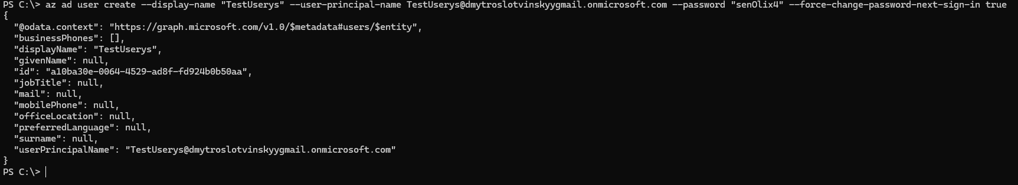

• Assign the Reader role to testuser@example.com for a specific resource group using Azure CLI. 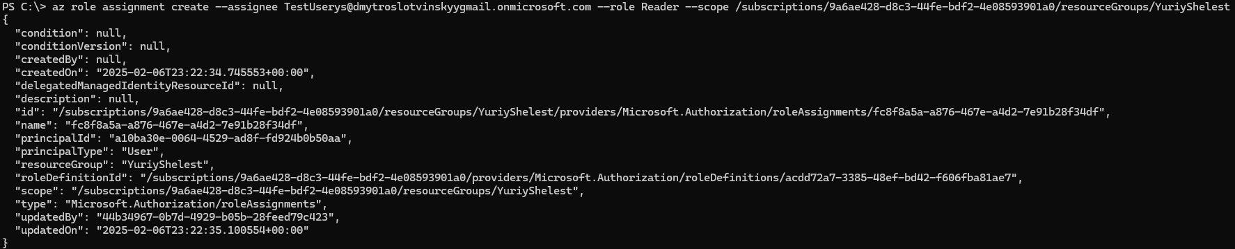 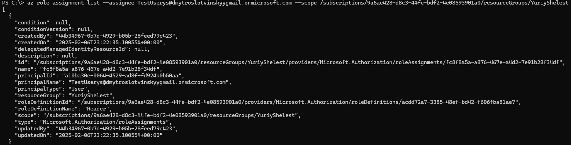 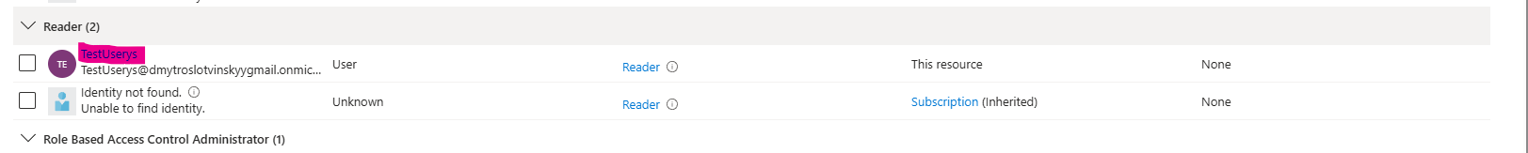

• Use Azure PowerShell to assign the Contributor role to testuser@example.com for a specific storage account. 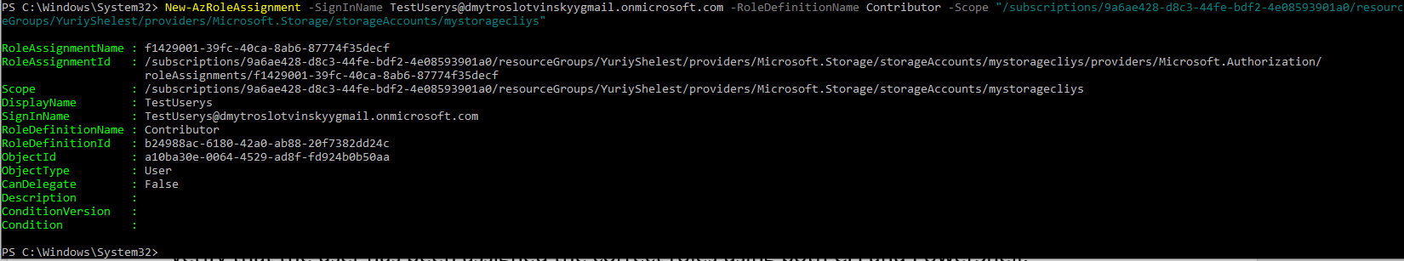

• Verify that the user has been assigned the correct roles using both CLI and PowerShell. 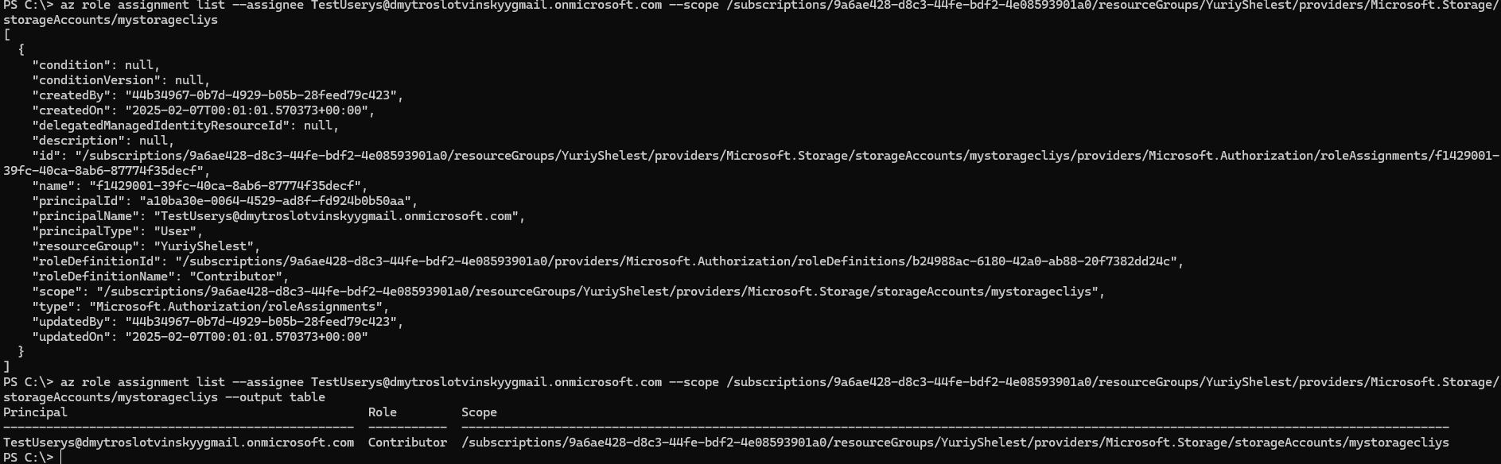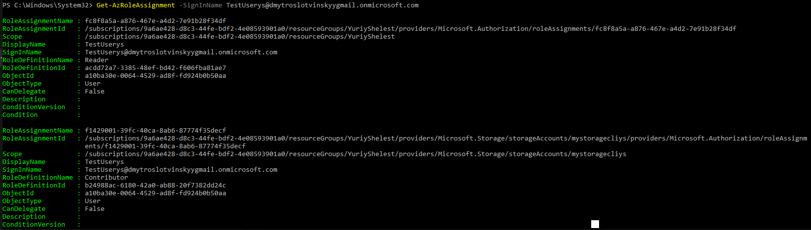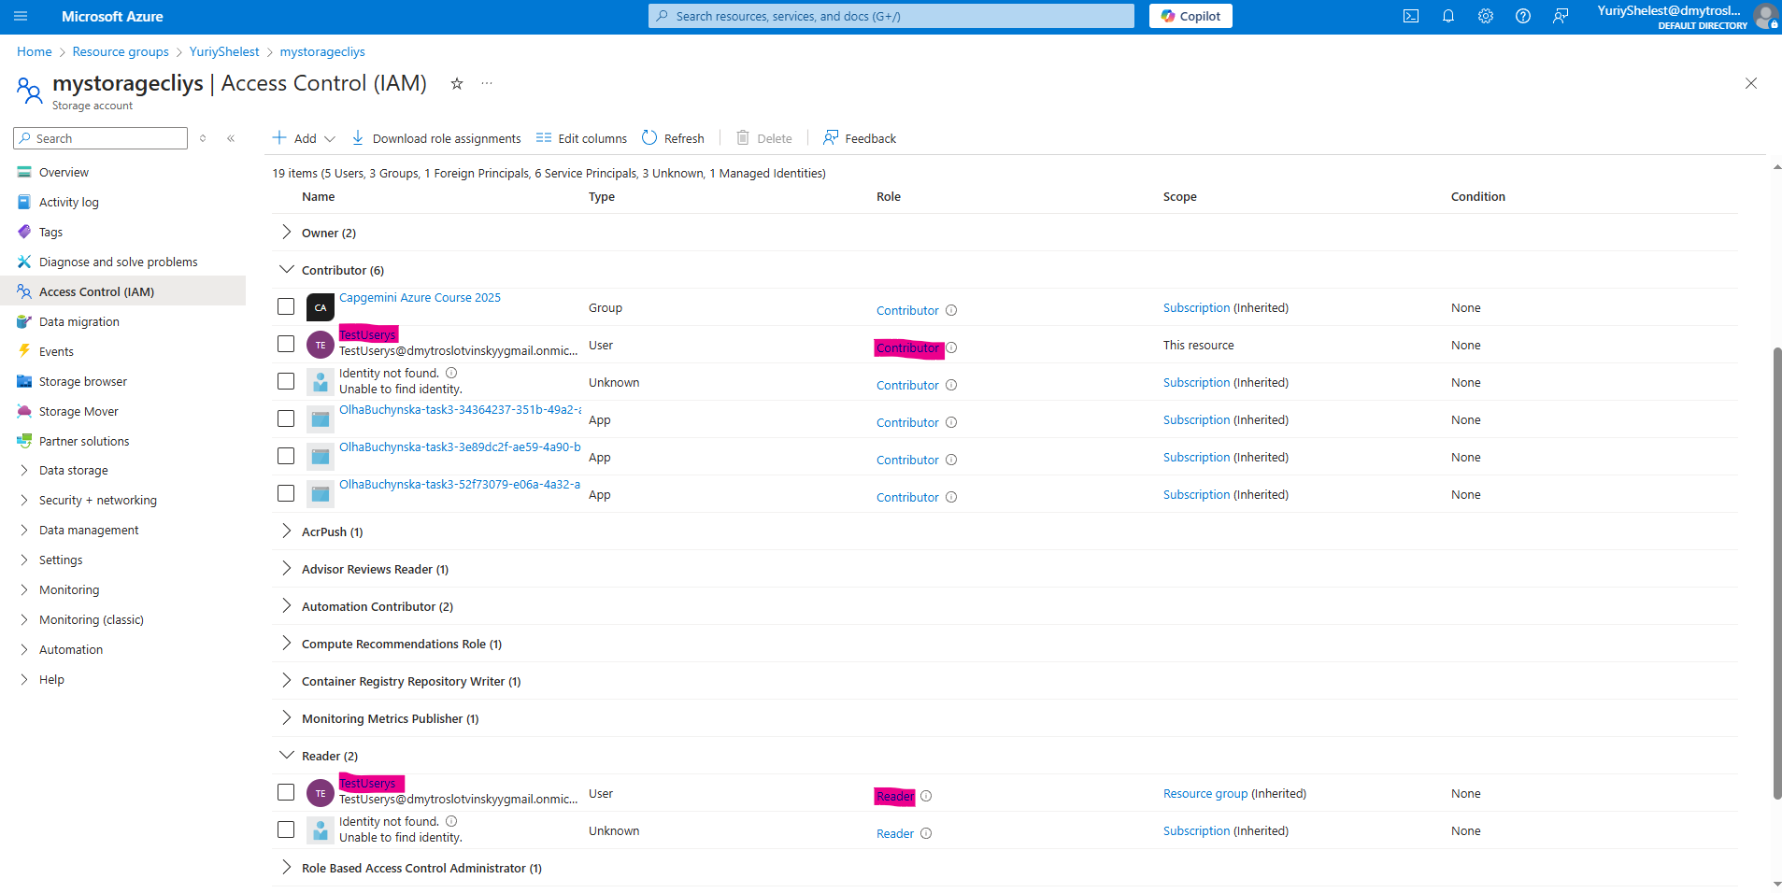

• Remove the user’s role assignments using the respective tools.  

**Practical Task 6:** Set Up a Scalable Web Server with VM, Storage, and Networking Requirements:

• Create a Resource Group

• Use Azure CLI to create a resource group named WebServerGroup in the East US region.

• Deploy a Virtual Network (VNet) and Subnet

• Use Azure CLI to create a virtual network named WebVNet in WebServerGroup.

• Add a subnet named WebSubnet.

• Create a Storage Account for Logs

• Use Azure PowerShell to create a storage account named webserverlogs in WebServerGroup.

• Enable blob storage and set up a container named logs for storing application logs.

• Deploy a Virtual Machine as a Web Server

• Use Azure CLI to create a virtual machine named WebVM in WebServerGroup.

• Configure WebVM to use the WebVNet and WebSubnet.

• Open port 80 on the VM for web traffic.

• Install and Configure Nginx on the VM

• Use Azure CLI to execute a script on WebVM that installs and configures Nginx as a web server.

• Enable Diagnostics and Store Logs in Storage Account

• Use Azure PowerShell to enable diagnostics on WebVM, directing logs to webserverlogs storage account.

• Verify the Web Server is Running

• Retrieve the public IP of WebVM using Azure CLI.

• Access the Nginx default page from a web browser using http://.

• Clean Up Resources

• Delete all created resources (WebVM, webserverlogs, WebVNet, WebServerGroup) using both Azure CLI and PowerShell.

**Practical Task 7:** Create and Run an Azure Automation Runbook Requirements:

• Create an Azure Automation Account named MyAutomationAccount in the East US region using Azure CLI. 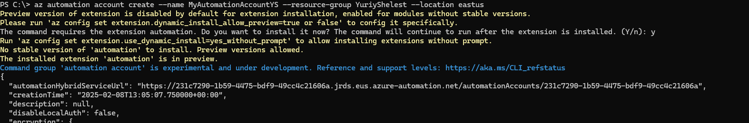

• Create a PowerShell Runbook named StartAzureVMRunbook inside MyAutomationAccount. 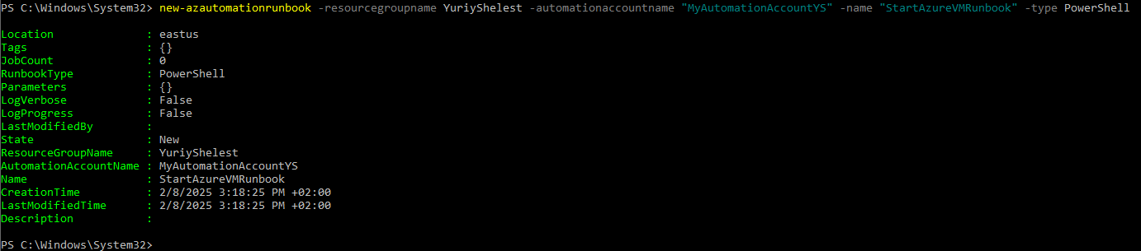

• Edit the Runbook to start a specified Azure Virtual Machine when executed. 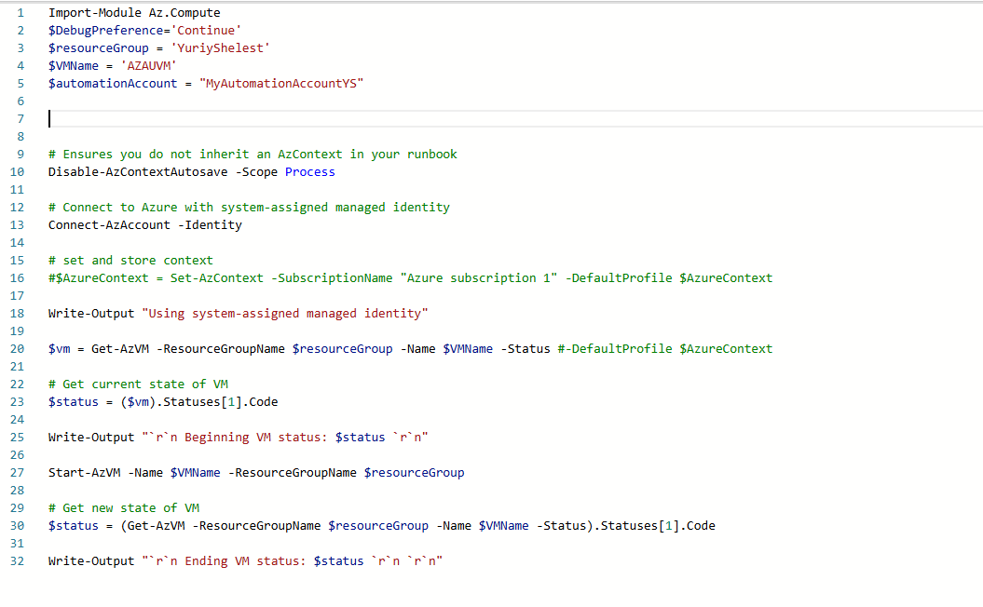

• Test the Runbook manually by executing it and verifying that the VM starts. 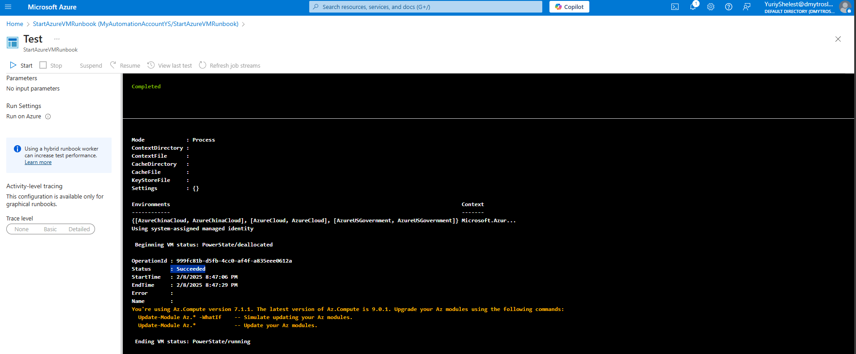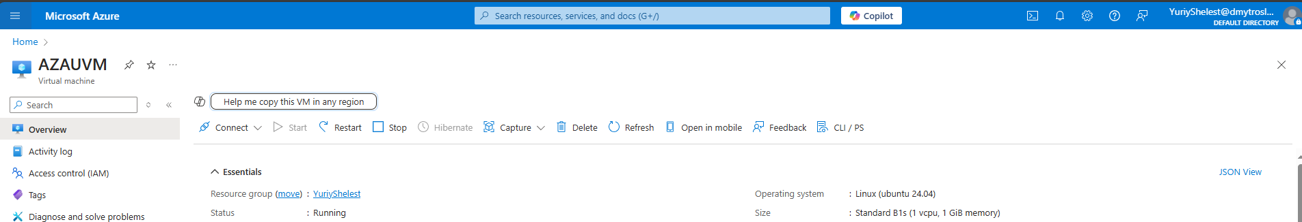

• Publish the Runbook and set up a schedule to automatically run it every day at 6:00 AM. 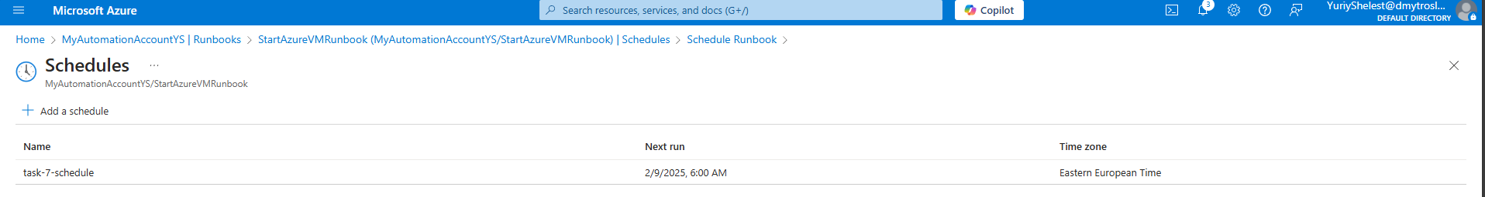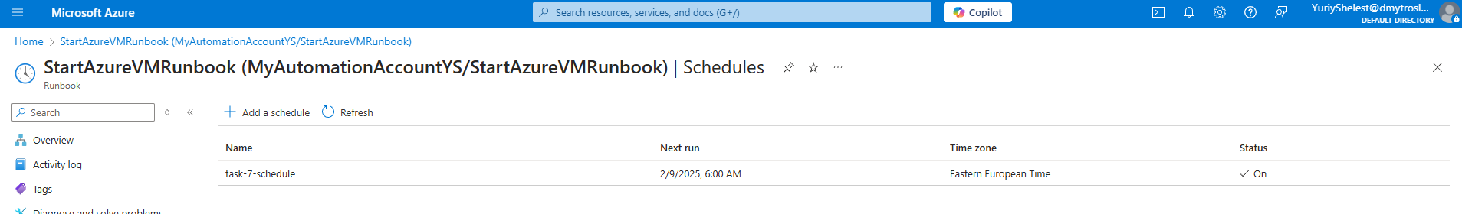 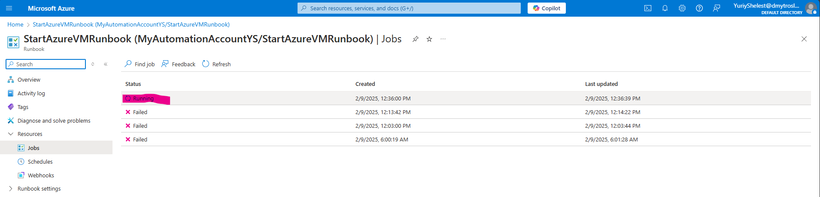 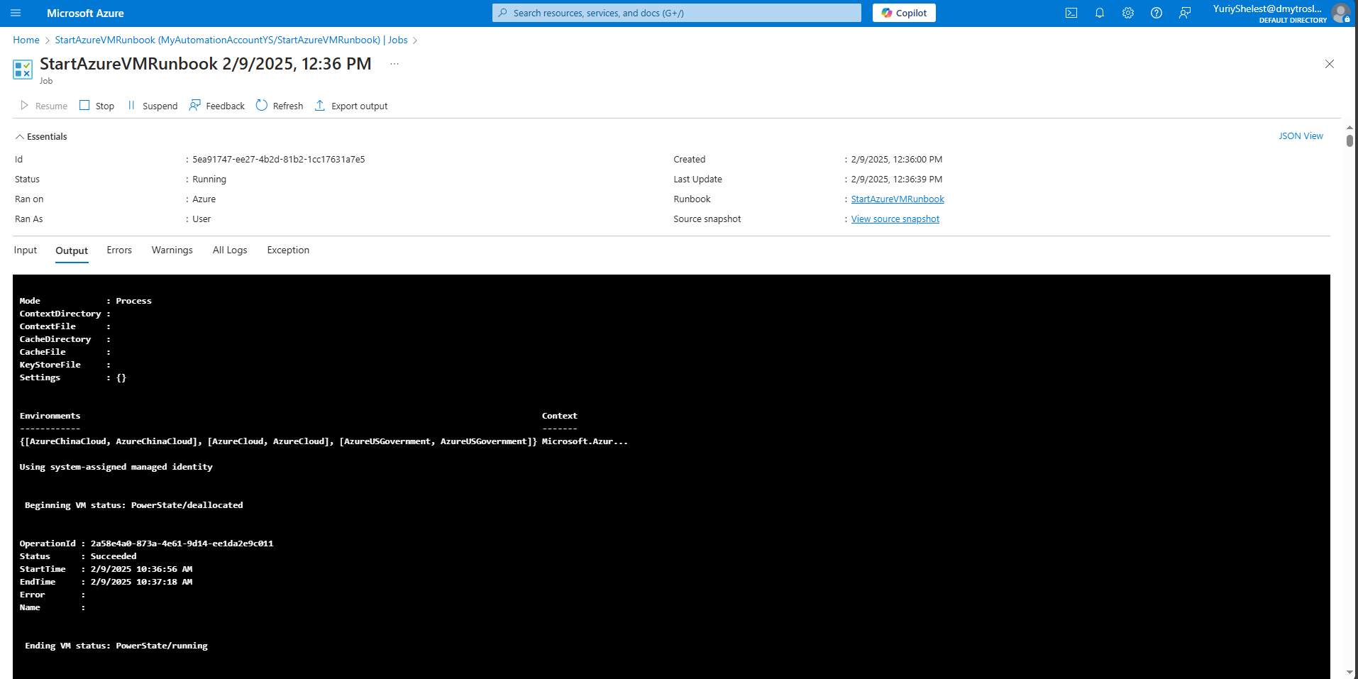

**Practical Task 8:** Automate Resource Cleanup Using a PowerShell Runbook Requirements:

• Create a new Runbook named CleanupOldResources in MyAutomationAccount. 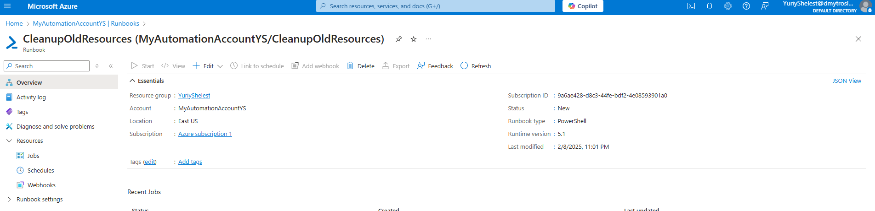

• Write a PowerShell script that:

o Lists all resource groups that have not been used in the past 30 days.

o Deletes unused resource groups after user confirmation.

▪ Test the Runbook in Azure Automation.

▪ Publish the Runbook and configure a webhook to trigger it on demand.

▪ Call the webhook using Azure CLI and verify the cleanup process.

**Practical Task 9:** Implement Desired State Configuration (DSC) to Enforce VM Settings Requirements:

• Create a new Azure Automation DSC Configuration named MyDSCConfig. 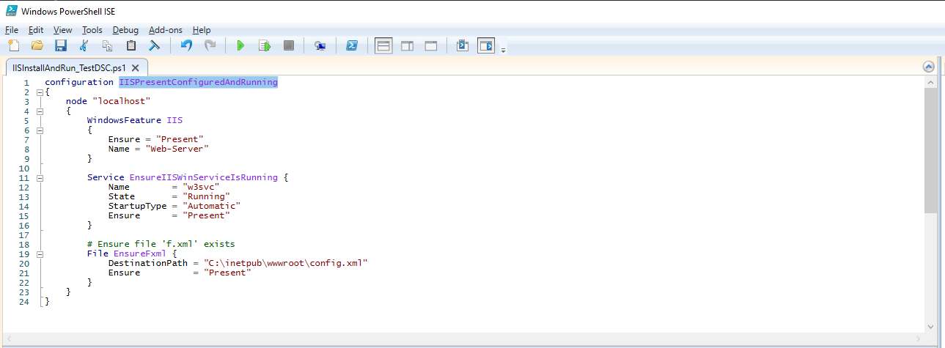 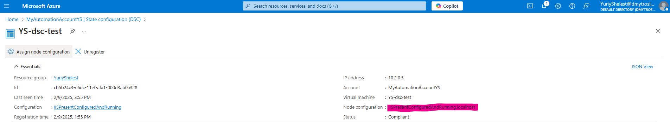

• Define a DSC script that:

o Ensures the Windows feature Web-Server (IIS) is installed on a Windows VM. 

o Ensures a specific configuration file (C:\inetpub\wwwroot\config.xml) exists with predefined content. 

• Ensures that a required Windows service (e.g., w3svc) is always running. 

o Compile and publish the DSC configuration in Azure Automation. 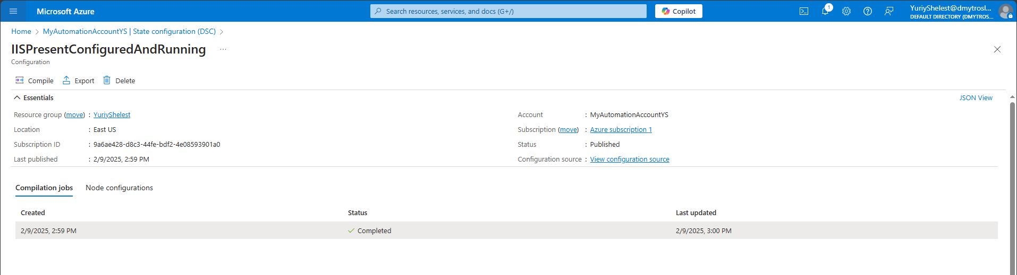

o Assign the DSC configuration to an existing VM and verify compliance. 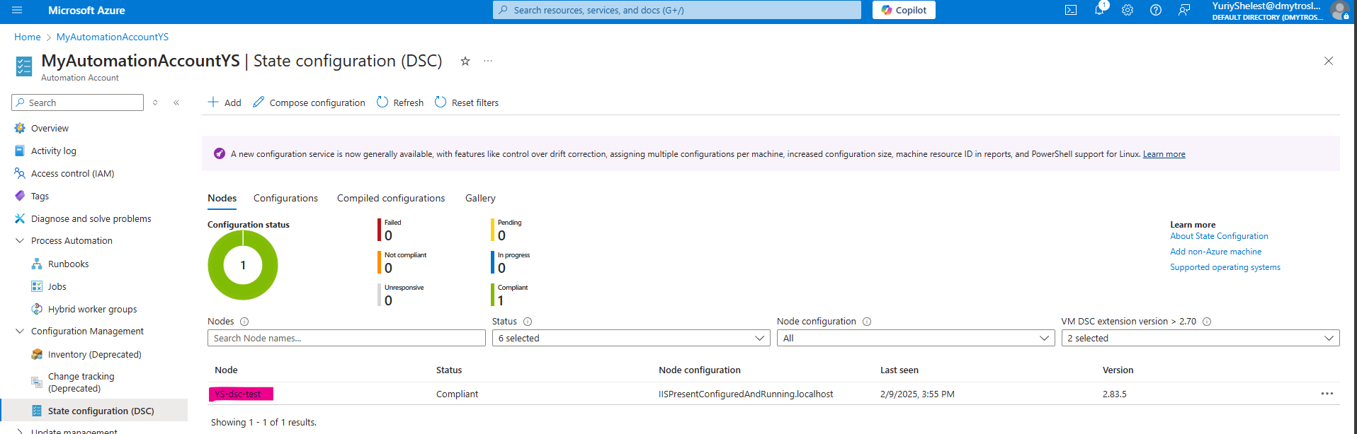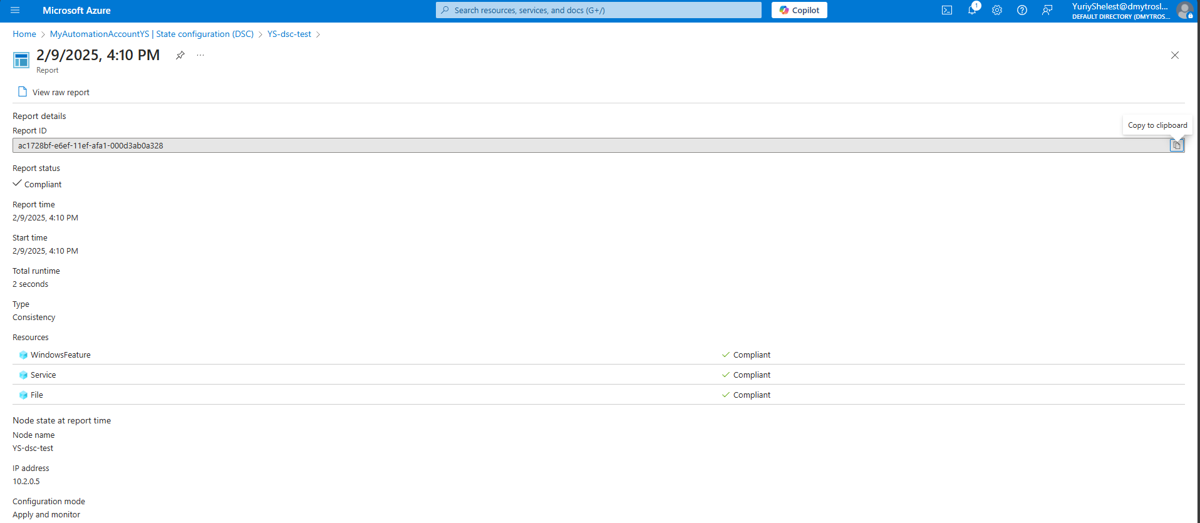

o Force a non-compliant state (e.g., stop the service or delete the config file), then observe Azure Automation remediating the issue automatically. 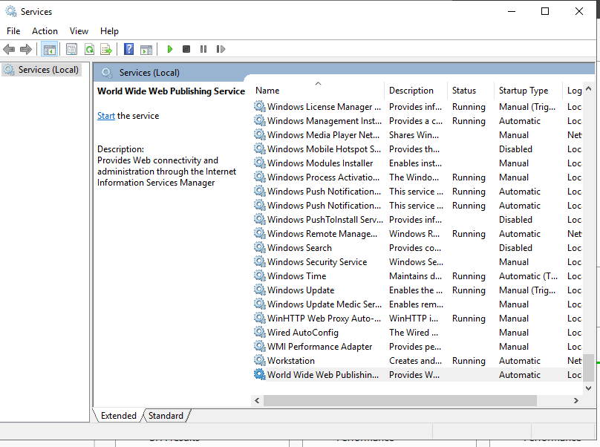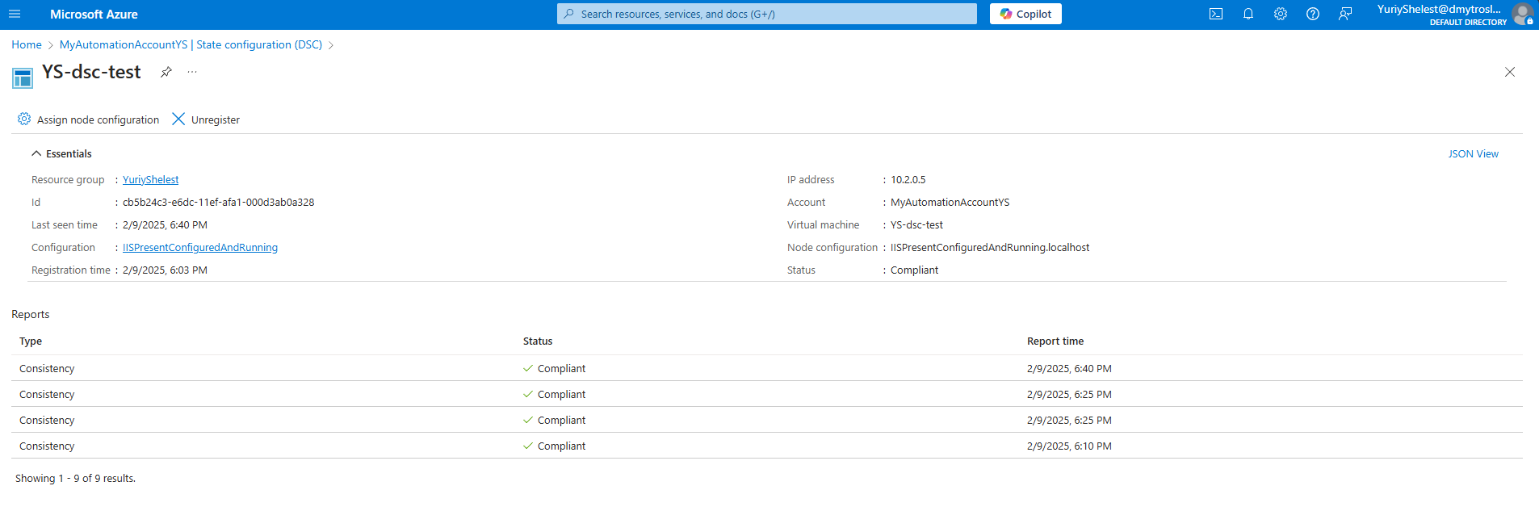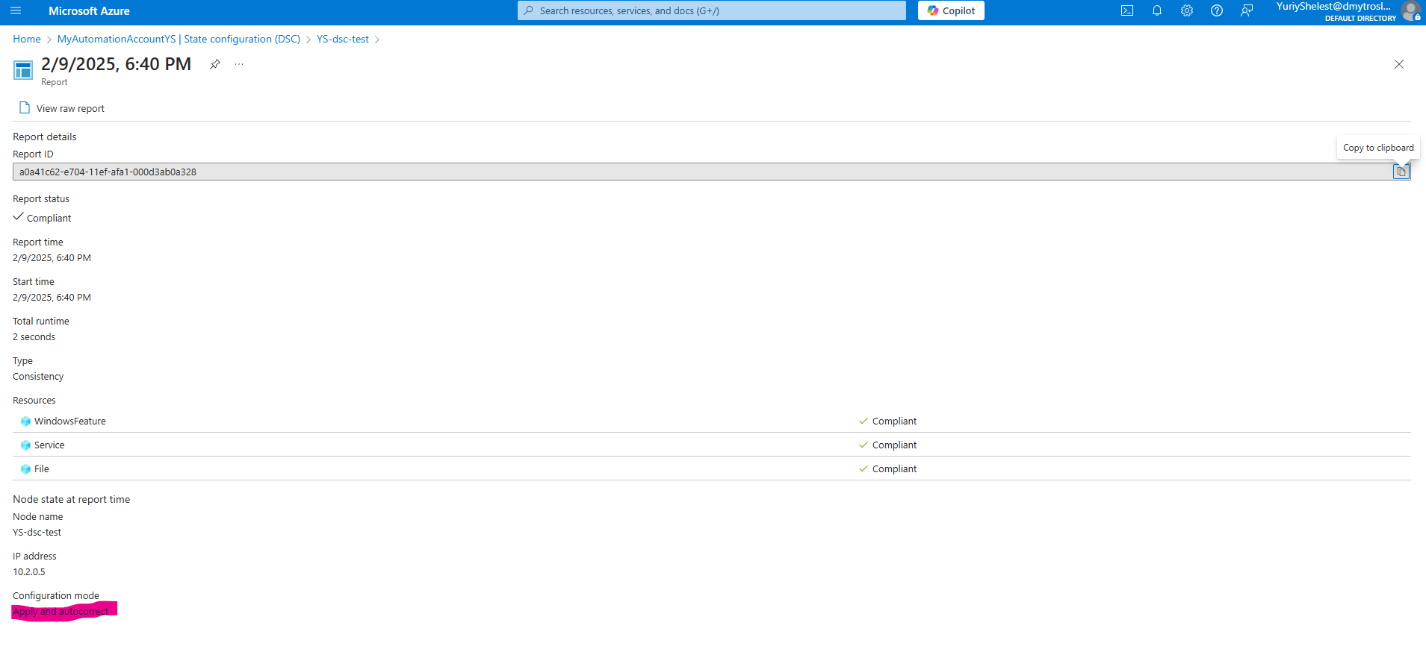

**Practical Task 10:** Automate Multi-Resource Deployment and Configuration Using Runbooks and DSC Requirements:

• Create a new Runbook named DeployAndConfigureWebServer.

• Inside the Runbook, automate the following tasks:

o Create a new VM named WebServerVM.

o Attach a managed disk to WebServerVM.

• Deploy a DSC configuration to ensure IIS is installed and a website is running.

o Publish and execute the Runbook, ensuring the web server is deployed and configured automatically.

o Verify the deployment by accessing the website hosted on the VM via its public IP address.

o Implement logging within the Runbook to track execution progress